Property Dealer CRM System
Course: CS-4032 Web Programming
Assignment: 03
Student Name: Humayun Bilal
Roll No: 23i-0832
Section: D
1. Project Overview
The Property Dealer CRM system is a full-stack web application designed to help property dealers manage leads efficiently. The system centralizes leads received from multiple sources (Facebook Ads, Walk-ins, Website inquiries) and provides tools to assign leads, track progress, score priority, and analyze performance.
2. Technologies Used
- Frontend: Next.js (App Router), Tailwind CSS
- Backend: Next.js API Routes, MongoDB + Mongoose
- Auth: JWT (cookie-based) + RBAC
- Real-time: Polling (fallback)
- Email: Nodemailer
- Other: Zod validation, PDF/CSV export
3. Core Features Implemented
- Authentication (Signup/Login/Logout)
- Role-Based Access (Admin / Agent)
- Lead CRUD + Scoring
- Assignment + Reassignment
- Activity Timeline (Audit Log)
- Smart Follow-up Tracking
- Analytics Dashboard
- Export Leads (CSV/PDF)
- AI-style Follow-up Suggestions
Screenshots Section
4. Admin Dashboard (Analytics Overview)
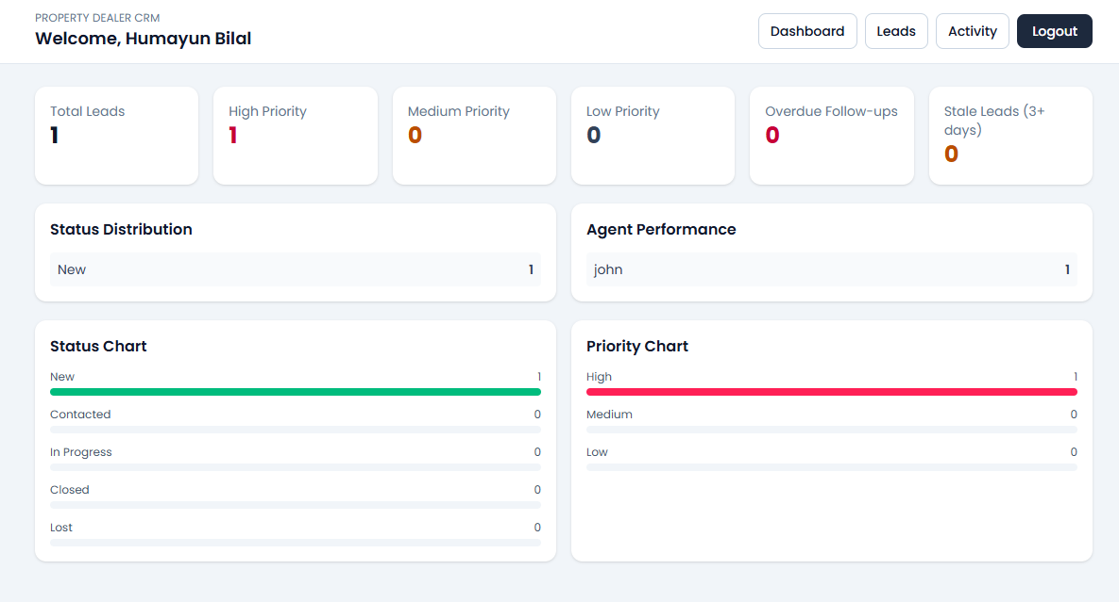
5. Activity Section
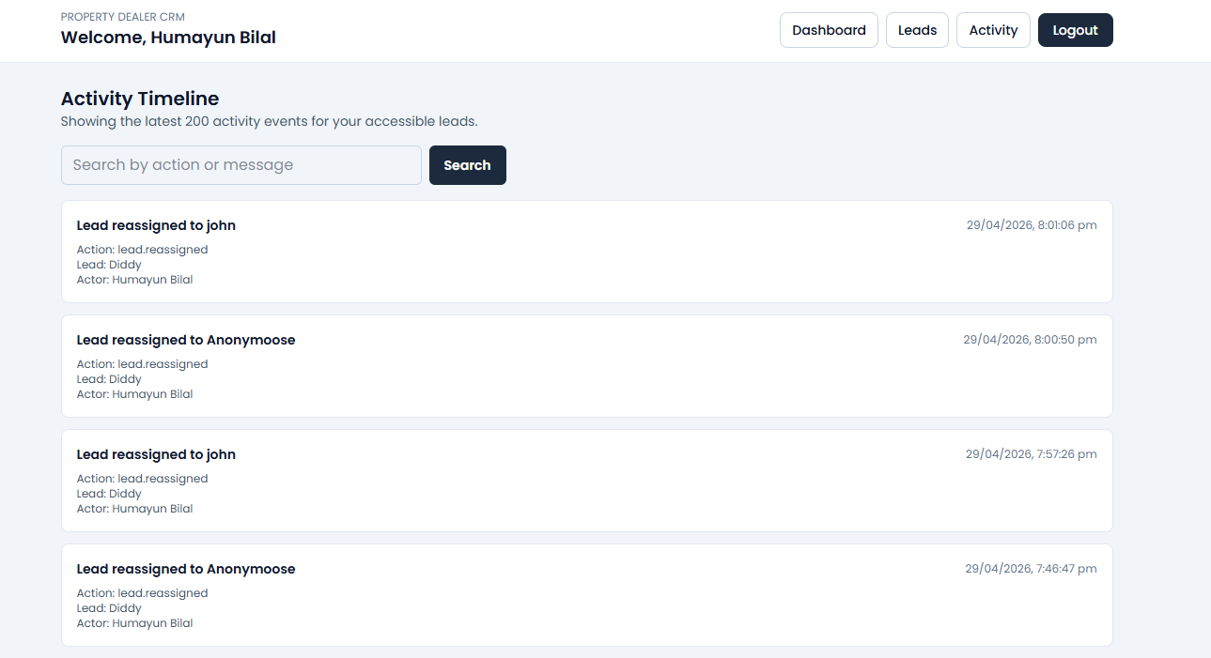

6. Leads Management (Admin)
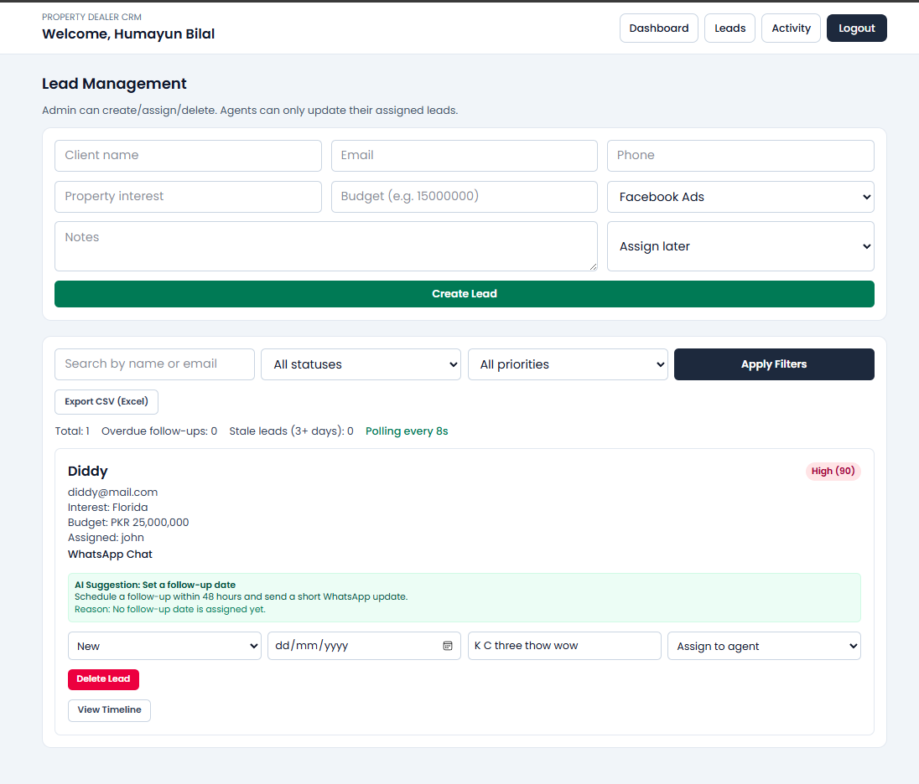
7. Login page
